**NAME-TASMIYA FATHIMA**

**USN-1BM19CS172**

**PROGRAM-2(BANKING DATABASE)**

**QUERIES**

create database banking_enterprise;

use banking_enterprise;

create table Branch(

branchname varchar(30),

branchcity varchar(30),

assets real,

primary key(branchname));

desc Branch;

create table BankAccount(

accno integer,

branchname varchar(30),

balance real,

primary key(accno),

foreign key(branchname) references Branch(branchname));

desc BankAccount;

create table BankCustomer(

customername varchar(30),

customerstreet varchar(30),

customercity varchar(30),

primary key(customername));

desc BankCustomer;

create table Depositer(

customername varchar(30),

accno integer,

primary key(customername, accno),

foreign key(customername) references BankCustomer(customername),

foreign key(accno) references BankAccount(accno));

desc Depositer;

create table Loan(

loannumber int,

branchname varchar(30),

amount real,

primary key(loannumber),

foreign key(branchname) references Branch(branchname));

desc Loan;

insert into Branch values('SBI_Chamarajpet','Bangalore',50000);

insert into Branch values('SBI_ResidencyRoad','Bangalore',10000);

insert into Branch values('SBI_ShivajiRoad','Bombay',20000);

insert into Branch values('SBI_ParliamentRoad','Delhi',10000);

insert into Branch values('SBI_Jantarmantar','Delhi',20000);

commit;

select * from Branch;

insert into Loan values(1,'SBI_Chamarajpet',1000);

insert into Loan values(2,'SBI_ResidencyRoad',2000);

insert into Loan values(3,'SBI_ShivajiRoad',3000);

insert into Loan values(4,'SBI_ParliamentRoad',4000);

insert into Loan values(5,'SBI_Jantarmantar',5000);

commit;

select * from Loan;

insert into BankAccount values(1,'SBI_Chamarajpet',2000);

insert into BankAccount values(2,'SBI_ResidencyRoad',5000);

insert into BankAccount values(3,'SBI_ShivajiRoad',6000);

insert into BankAccount values(4,'SBI_ParliamentRoad',9000);

insert into BankAccount values(5,'SBI_Jantarmantar',8000);

insert into BankAccount values(6,'SBI_ShivajiRoad',4000);

insert into BankAccount values(8,'SBI_ResidencyRoad',4000);

insert into BankAccount values(9,'SBI_ParliamentRoad',3000);

insert into BankAccount values(10,'SBI_ResidencyRoad',5000);

insert into BankAccount values(11,'SBI_Jantarmantar',2000); 4,5,9,11

commit;

select * from BankAccount;

insert into BankCustomer values('Avinash','Bull_Temple_Road','Bangalore');

insert into BankCustomer values('Dinesh','Bannerghatta_Road','Bangalore');

insert into BankCustomer values('Mohan','NationalCollegeRoad','Bangalore');

insert into BankCustomer values('Nikhil','Gulmohar_Marg','Delhi');

insert into BankCustomer values('Ravi','Prithviraj_Road','Delhi');

commit;

select * from BankCustomer;

insert into Depositer values('Avinash',1);

insert into Depositer values('Dinesh',2);

insert into Depositer values('Nikhil',4);

insert into Depositer values('Ravi',5);

insert into Depositer values('Avinash',8);

insert into Depositer values('Nikhil',9);

insert into Depositer values('Dinesh',10);

insert into Depositer values('Nikhil',11);

commit;

select * from Depositer;

select c.customername

from BankCustomer c

where exists(

select d.customername

from depositer d, BankAccount ba

where

d.accno=ba.accno and

c.customername=d.customername and

ba.branchname='SBI_ResidencyRoad'

group by d.customername

having count(d.customername)>=2

);

select d.customername from depositer d,BRANCH b,bankaccount a

where b.branchname=a.branchname

AND a.accno=d.accno

and branchcity='Delhi'

group by d.customername

HAVING COUNT(distinct b.branchname)=(

SELECT COUNT(branchname)

FROM branch

WHERE branchcity='Delhi');

delete from BankAccount

where branchname IN(

select branchname

from Branch

where branchcity='Bombay');

**SCREENSHOTS OF QUERIES:**

**Branch table:**

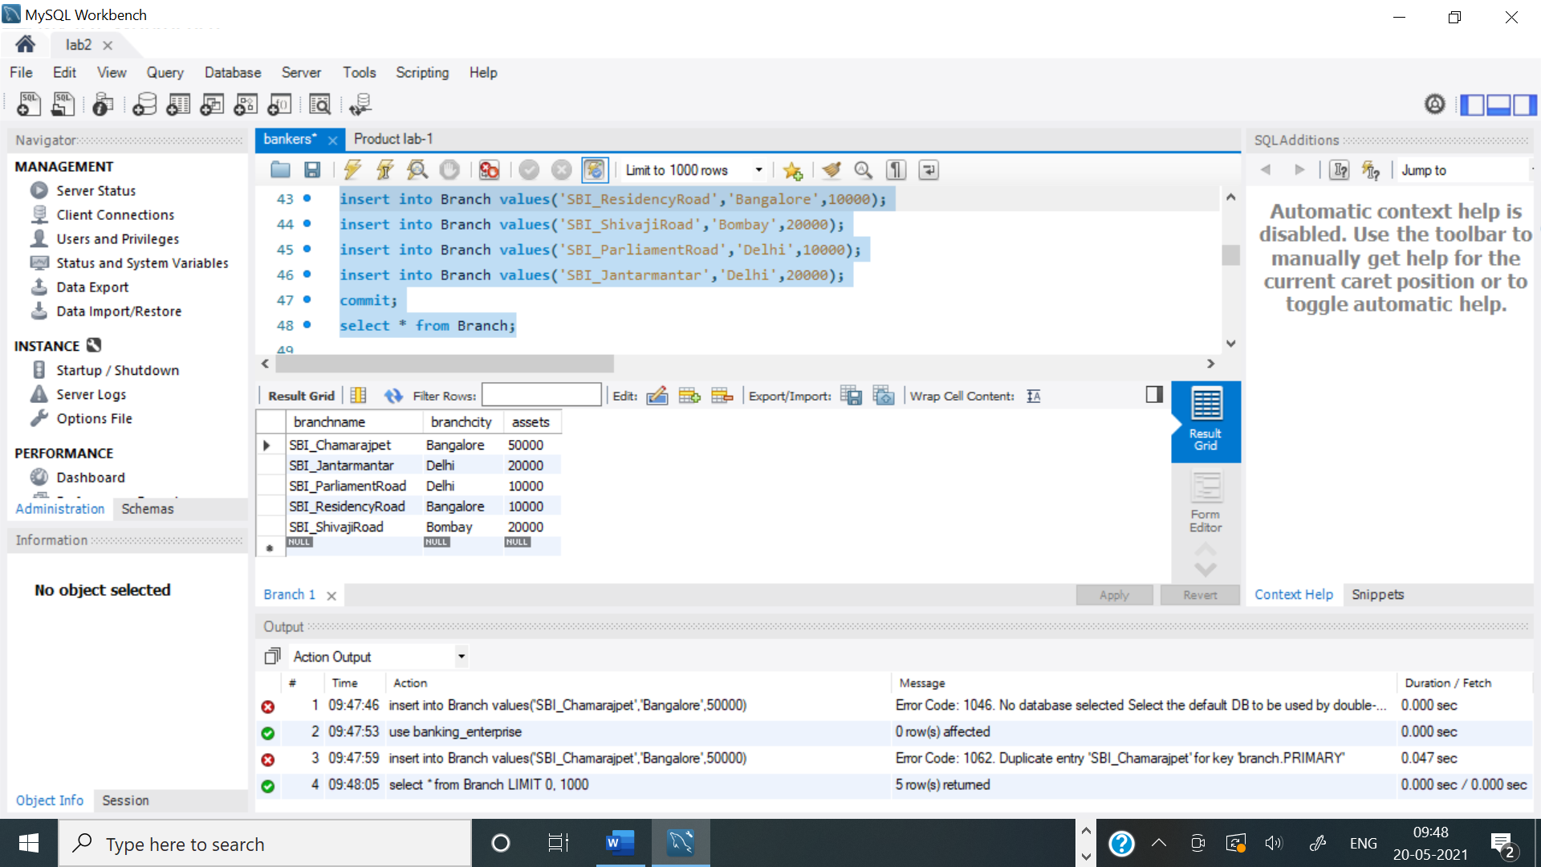

**Loan table:**

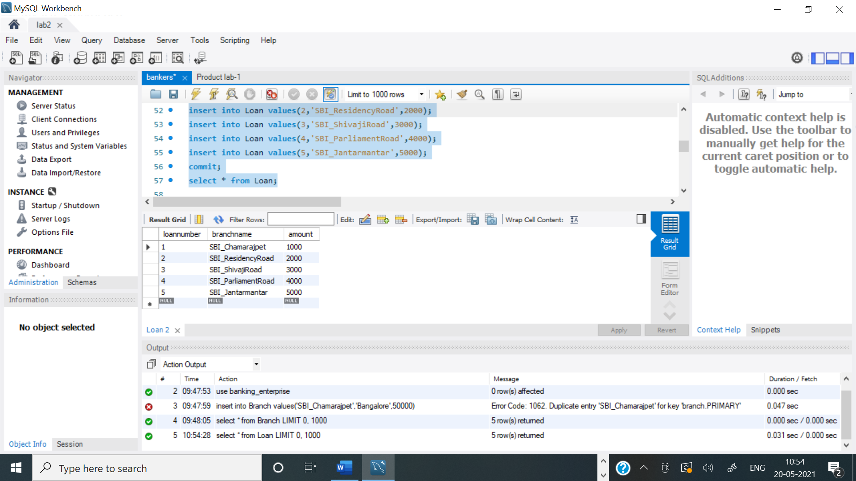

**BankAccount table:**

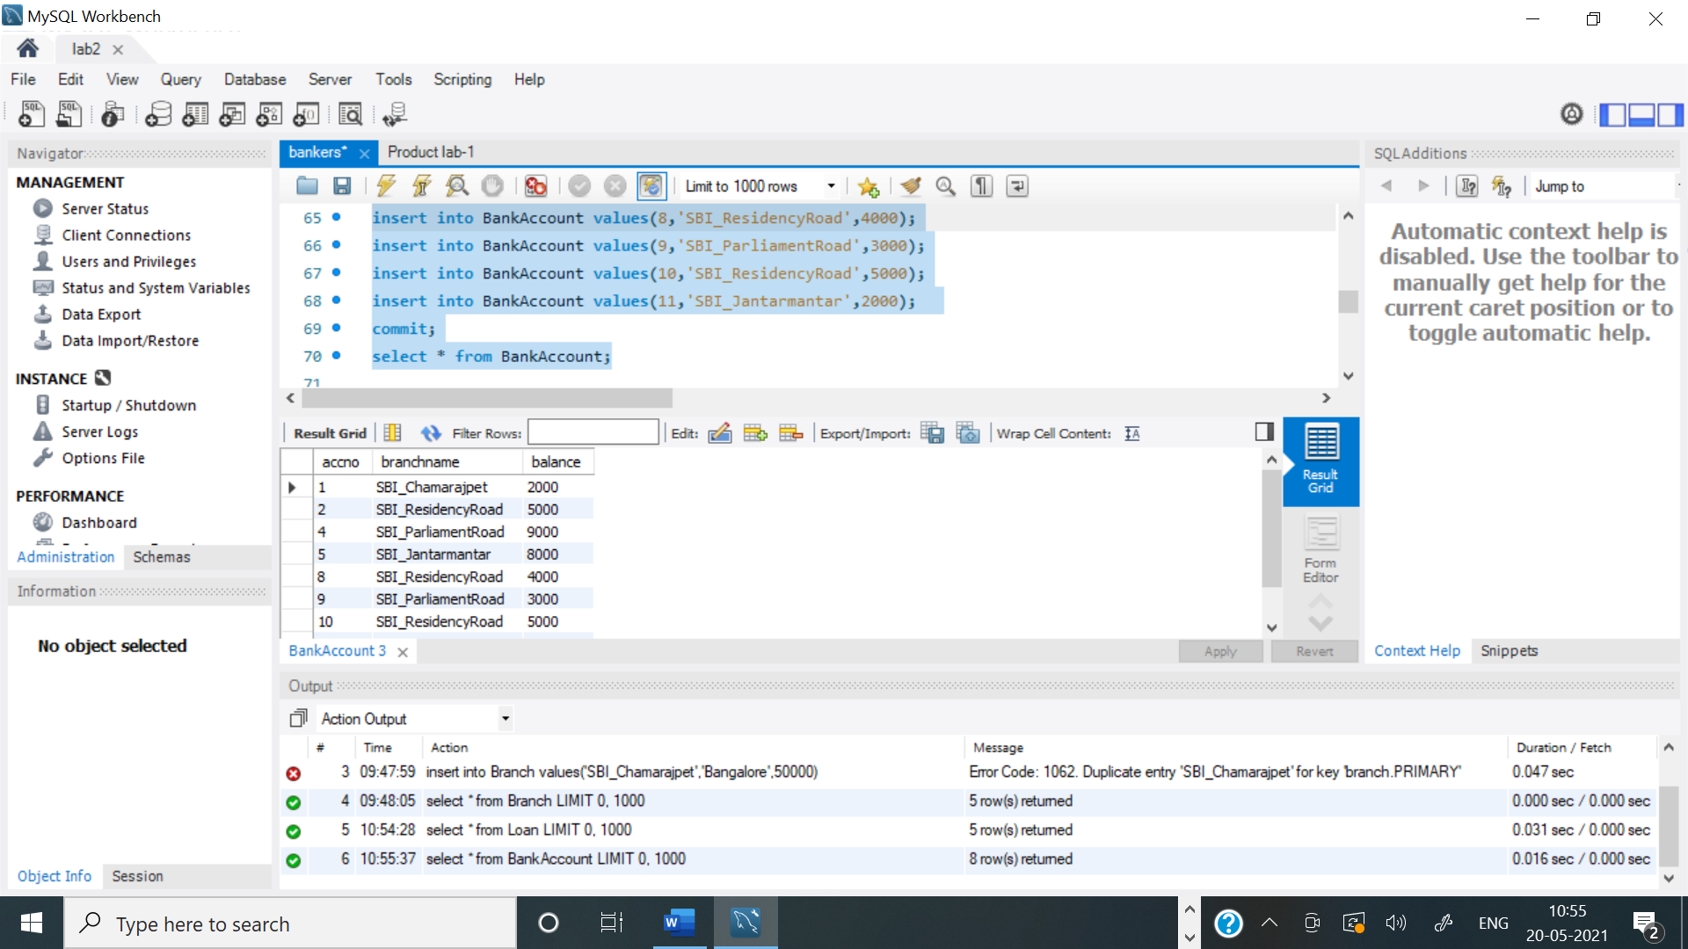

**BankCustomer table:**

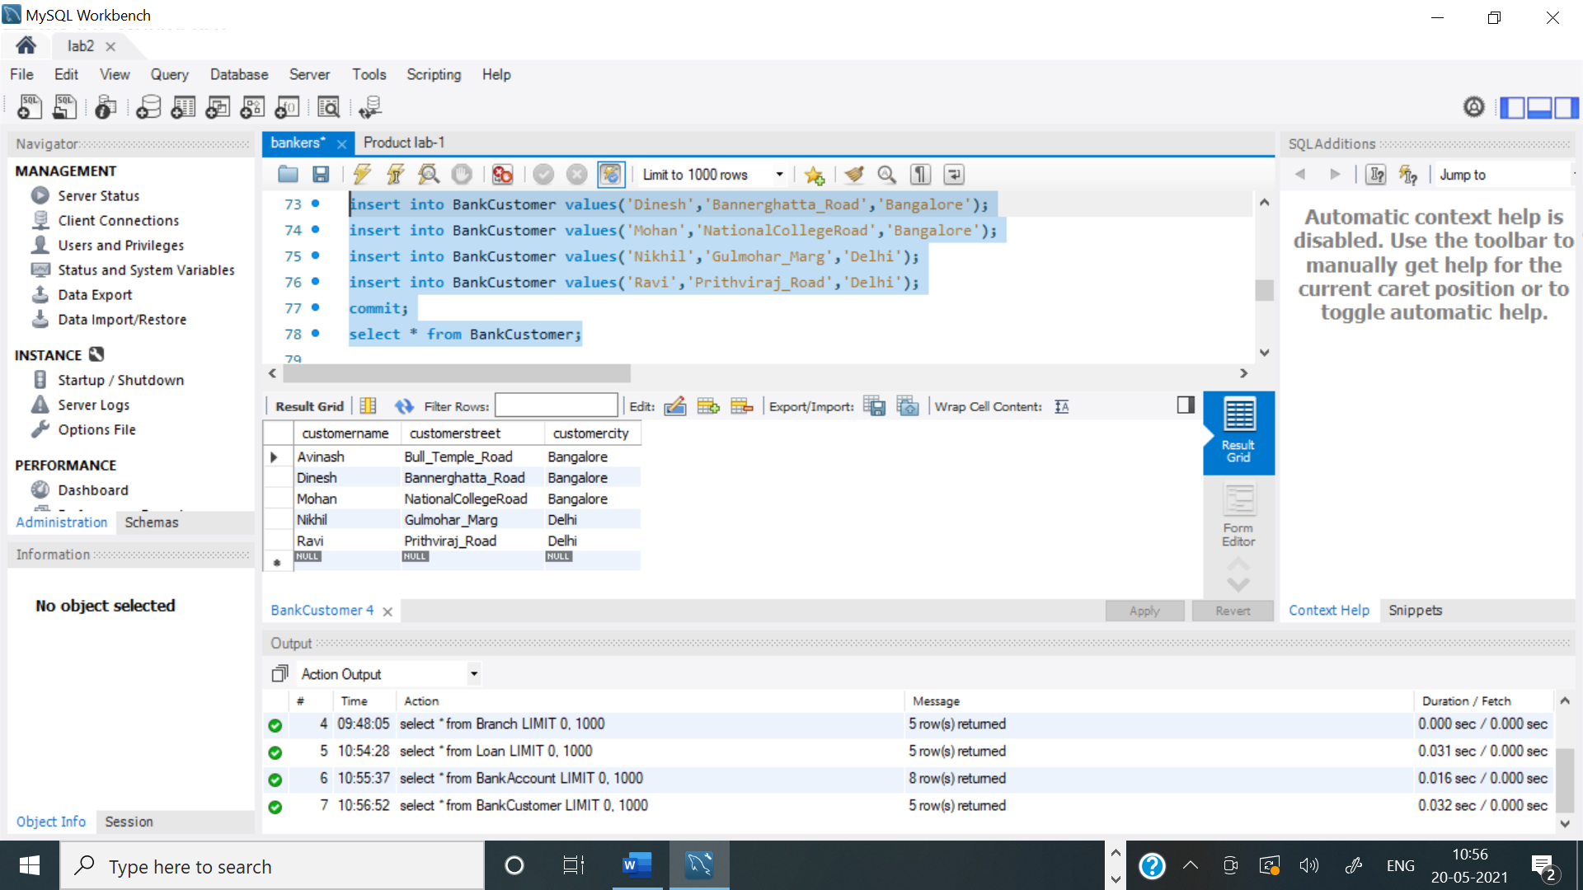

**Depositor table:**

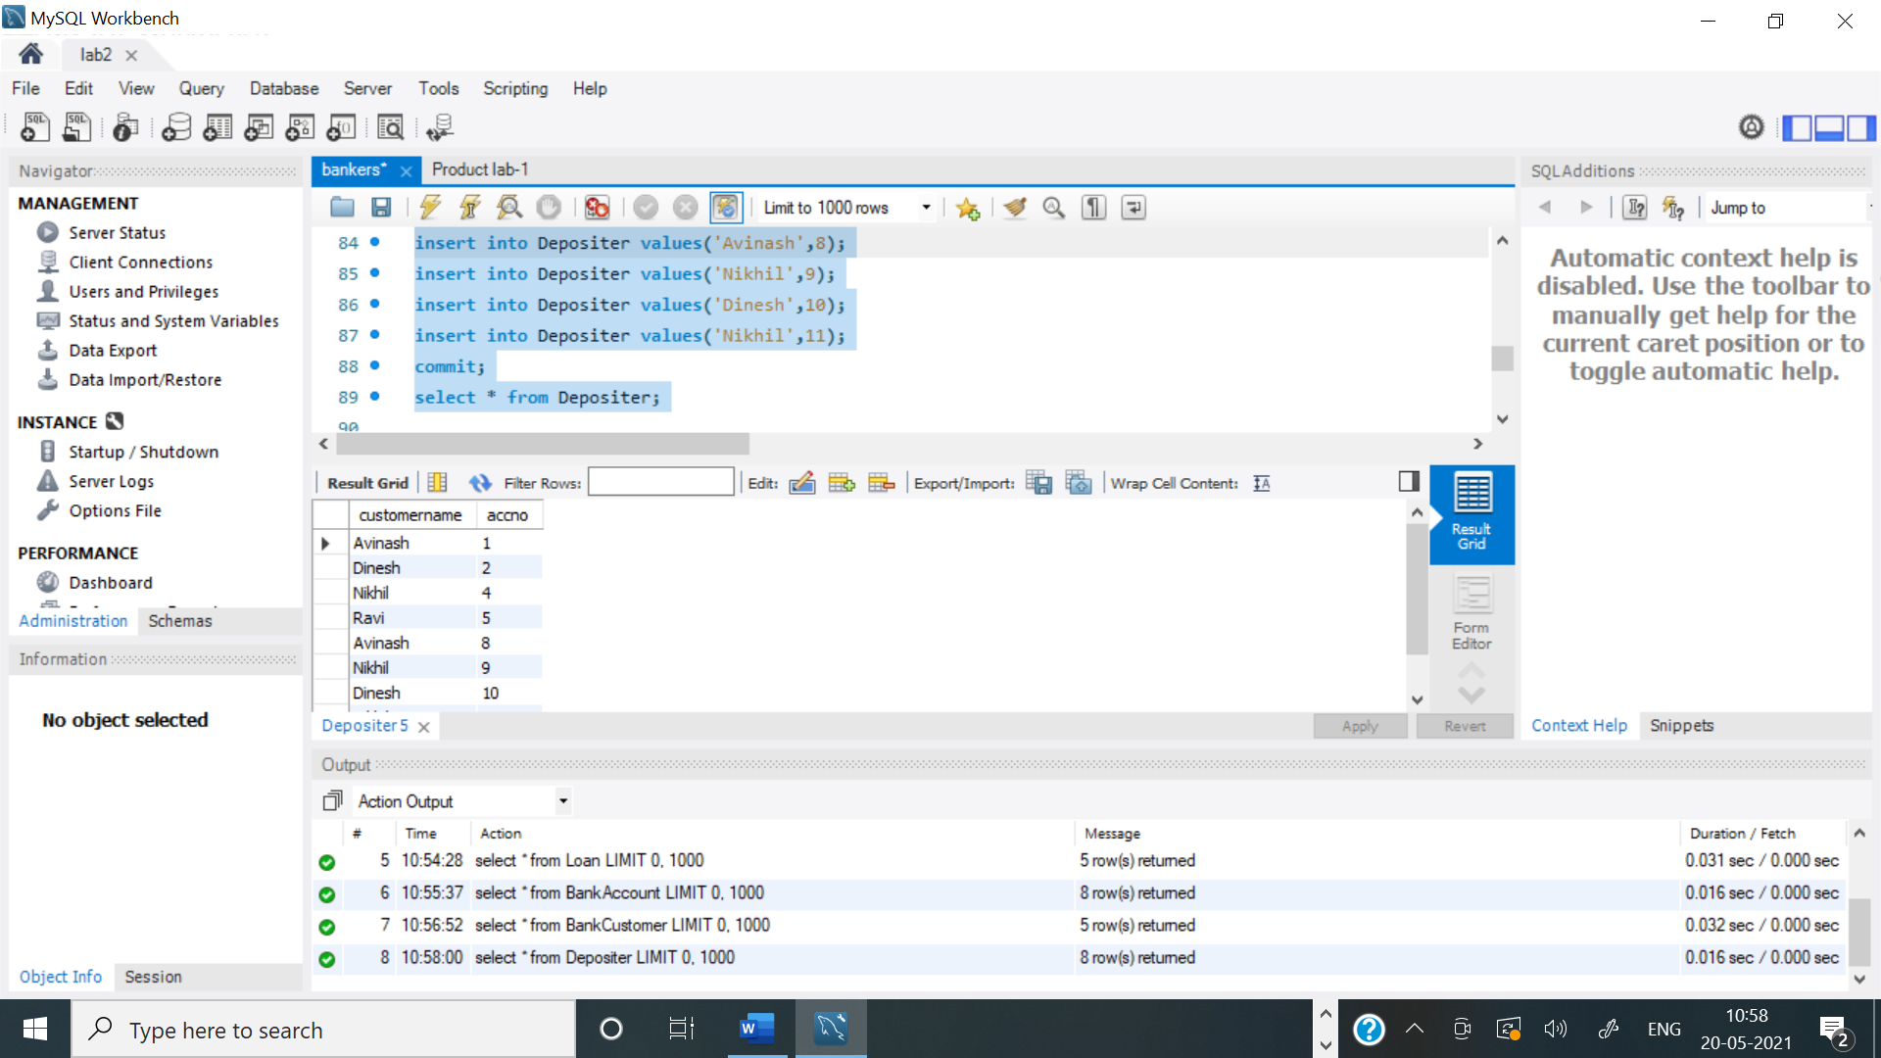

**Query 3:**

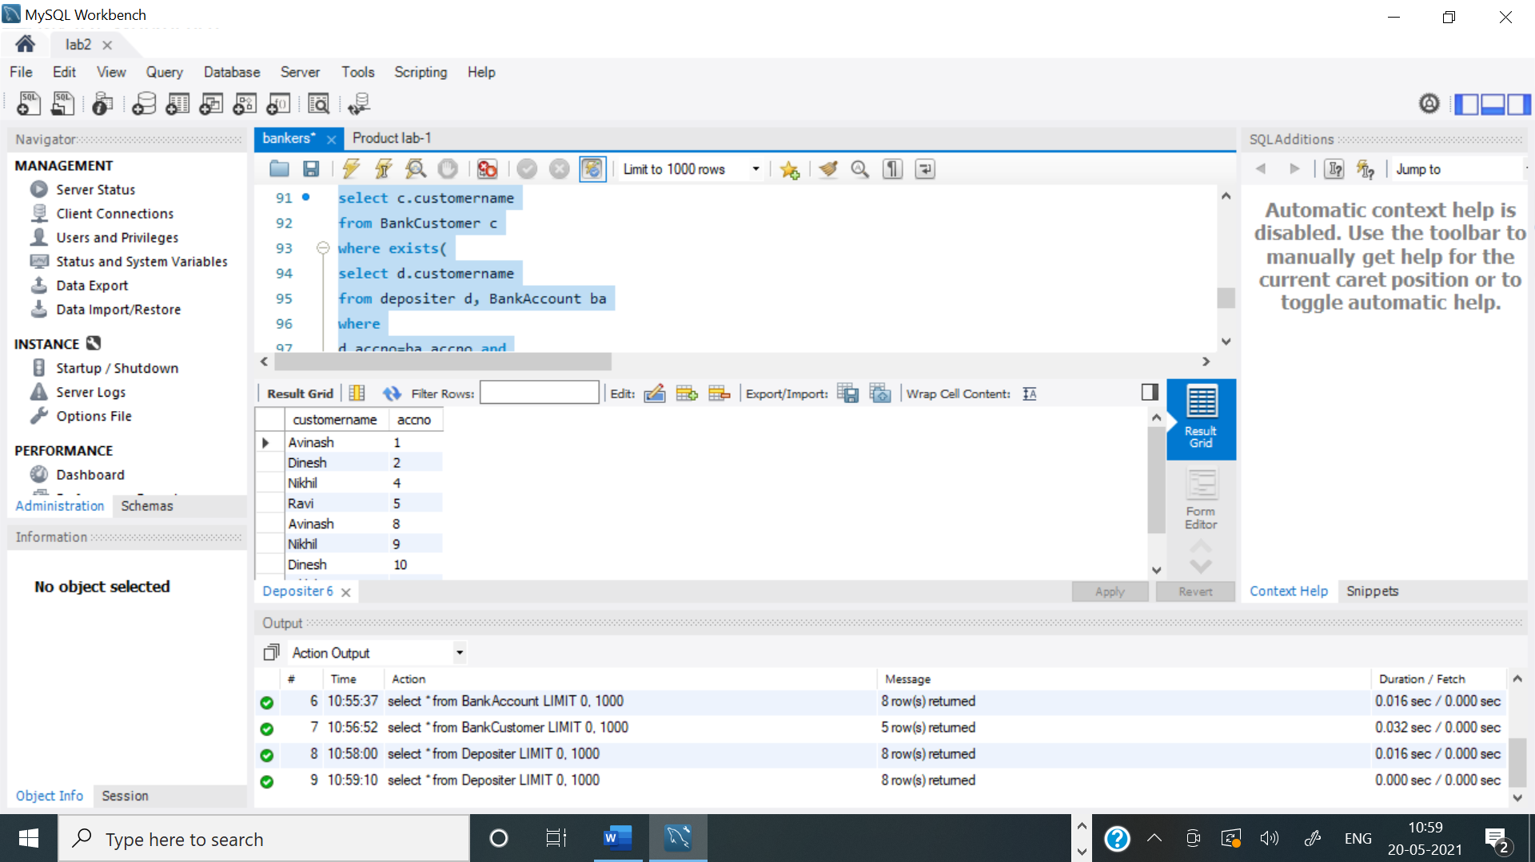

**Query 4:**

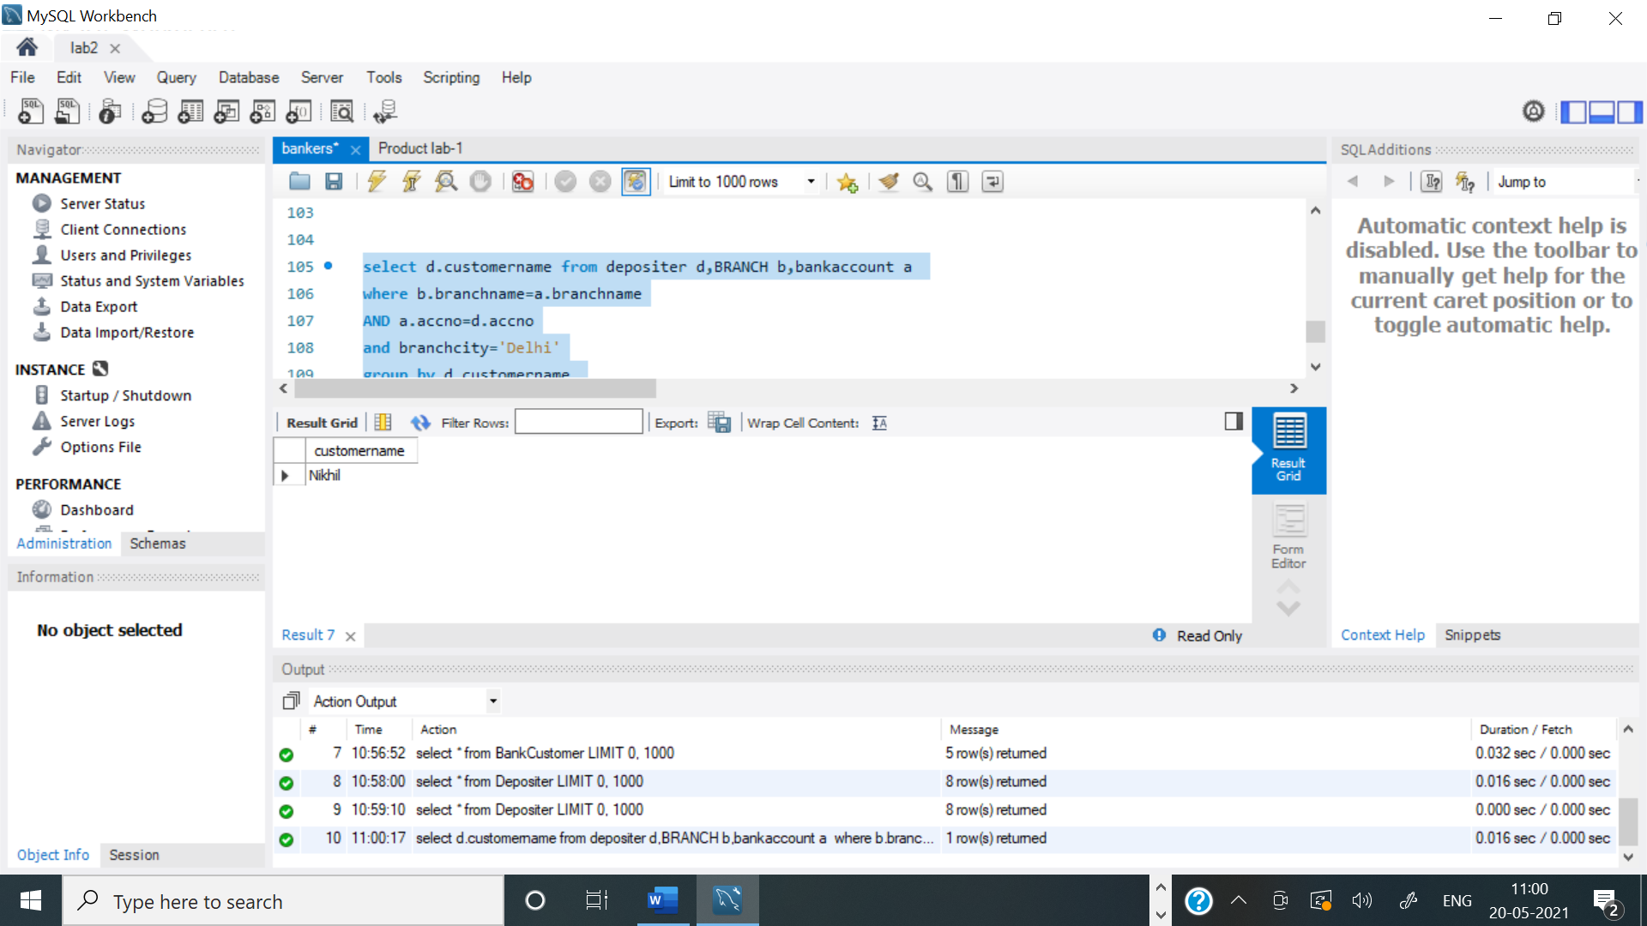

**Query 5:**

